Number Plate Recognition a for parking assist
and Road Safety

Senthil Pitchappan V  BE in Electonics and Communication Engineering  Velammal College of Engineering and Technology, Madurai  Senthilvalliappan99@gmail.com | Sree Harish Rajan A R  BE in Electonics and Communication Engineering  Velammal College of Engineering and Technology, Madurai  sreeharishar@gmail.com

Abstract— As an Engineer and an Indian citizen, Parking is major problem in our country as well in our surroundings such as Apartments, Educational Institutions etc. and also road Safety. This problem can be autonomously monitored. Vehicle parking is an important component within any transportation system, whereby vehicles are often parked at destinations. With an increased number of motor vehicles on roads especially in developing countries, there is need for a vehicle identification mechanism that is effective, affordable and efficient. In most academic institutions, apartments and car parks, the ongoing car park entry registration process for visitors, staff or students entering the institution involves a security guard having to confirm membership details by checking for membership sticker on the windscreen of the vehicle or by checking the driver's identification card. This process of writing is tedious and time consuming and is prone to inaccurate recordings, furthermore the backup and sharing of this vehicle information is difficult because the data is hard copy. This process can be automated using Image Processing and a dedicated Android Application for owners and Police men with automatic theft control, Email and messaging. Road Safety on other side is also done using the same application where the user can fail complaints regarding the traffic violations, accident, women harassments etc., which will be automatically updated in the police application. And he/she can take necessary decisions. Concluding, this proposed project can bring a new revolution in parking assist as well as road and women safety.

Keywords— Image Processing, Spyder, Firebase, MySQL, MIT App Inventor, Android Application, Raspberry Pi, Pi Cam/Web cam, Tableau.

Introduction
Vehicles are very dense in a populous country such as ours. The idea is to create smart solution to deal with modern problems. As there are many vehicles the government needs to monitor these vehicles for various parameters. It is nearly impossible to man the streets to catch up with the violators. So here we bring up our research on Image Processing of Number Plates, here using the image processing technology we are able to scan the number plates of the vehicles and identify the violators and file infractions on the person. So instead using separate police officers we use machine learning to lodge complains on the infatuate.

Parking is an important component within any transportation system, whereby vehicles must be parked at every destination. Most vehicles are parked most of the time during the day. Parking convenience is the ease of accessing a safe and preferable parking position, hence affecting the ease of reaching destinations. India which sees itself as a promising super power and an economic hub can achieve its goal if and only if a large number of women participate in the development process. This paper presents an analysis review on the principal need of intelligence security system with technology requirement and challenges to build the system. Since the prediction of such incident is not possible hence to minimize the possibility of physical violence (robbery, sexual assault etc.) by keeping all the help tools ready to safely escape from violent situation. This reduces risk and brings assistance when needed. The social networking is the part of our life and also a source for women harassment by uploading the offensive photograph taken by hidden cameras, even though these cases might happen with innocence males, in some such cases these guys end their life by committing a suicide.

Vehicle parking is an important component within any transportation system, whereby vehicles are often parked at destinations. With an increased number of motor vehicles on roads especially in developing countries, there is need for a vehicle identification mechanism that is effective, affordable and efficient. In most academic institutions, apartments and car parks, the ongoing car park entry registration process for visitors, staff or students entering the institution involves a security guard having to confirm membership details by checking for membership sticker on the windscreen of the vehicle or by checking the driver's identification card. This process of writing is tedious and time consuming and is prone to inaccurate recordings, furthermore the backup and sharing of this vehicle information is difficult because the data is hard copy.

Automatic number plate Detection
Automatic Number Plate Recognition is a process where
vehicles are identified or recognized using their number plate or license plate. ANPR uses image processing techniques so as to extract the vehicle number plate from digital images. ANPR systems normally comprise of two components: A 5mp camera with infrared and night vision is used in capturing of vehicle number plate images, and software that extracts the number plates from the captured images by using a character recognition tool that allows for pixels to be translated into numerical readable characters. A license plate recognition system generally works in four main parts namely image acquisition, license plate detection, characters segmentation, and lastly character recognition. It is a sequential process where first the original RGB image gets captured then the image gets converted into grayscale that is, it gets binarized. Then the image is filtered of noise and such similar undesired components. After the image is filtered the license plate image is specifically cropped out from the main image. After magnifying and selecting the image it then gets read by character segmentation that is done using open cv software where the image is considered and a separate layout is taken where the image gets segmented structure by structure until the whole segment is due processed.

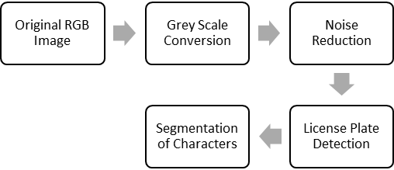

Fig 1: shows a typical ANPR process.

Image Acquisition
The first step is the image acquisition stage. The image of the vehicle is captured using a photographic camera. The
constraint is that the image of the vehicle should be captured
in such a way that the selected input image contains rear or
front view of the vehicle with the number plate. This process can also be done by capturing a video and defecting the image frame by frame to obtain the image. So by fixing suitable cameras at proper terminals we are definitely able to capture any said image through video processing. The image is usually captured in an RGB (Red, Green and Blue) colour model. The captured image is affected by many factors like: optical system, distortion, system noise, lack of exposure or excessive relative motion of camera or vehicle thus resulting in a degradation of a captured vehicle image hence adversely affecting the results of the overall image processing. As a correction mechanism, an image pre-
processing stage is introduced to take care of any errors that
may have occurred during the image acquisition stage. Image pre-processing mainly involves converting the RGB image into grey colour, noise removal, and border enhancement for brightness. Image pre–processing is usually done through image filtering.

image = cv2.imread('C:/Users/N/Desktop/Test.jpg')

Grey Scale Converison
In the 1st step we obtain the saved image from the camera image or an image from local files. Grey scale image is preferred because it displays the required part clearly without deflecting any minor unnecessary itinerary. Grey scaling an image is important because it surely does make the processing system easy to read the image and follow further instructions easily without any difficult hurdles that trouble the processor in processing. Next we convert the image into gray scale image using Open-CV, a python-based image processing library file.
cv2.imshow('Gray image', gray)

Filtering of Image(blur)
A bilateral filter is used for smoothening images and reducing noise, while preserving edges. It is easy to note that all these denoising filters smudge the edges, while Bilateral Filtering retains them. Image blurring is achieved by convolving the image with a low-pass filter kernel. It is useful for removing noise. These noises tend to infect the image with interference which may lead to erroneously readings. It removes high frequency content (e.g: noise, edges) from the image resulting in edges being blurred when this is filter is applied.

Blur = cv2.bilateral(gray,11,90,90)

- Canny Edge Detection
Canny Edge Detection is a popular edge detection algorithm. It was developed by John F. Canny in 1986. It is a multi-stage algorithm. OpenCV puts all the above in single function, cv2.Canny(). We will see how to use it. First argument is our input image. Second and third arguments are our minVal and maxVal respectively.

Edges = cv2.canny(blur,30,200)

- Contouring
Contours can be explained simply as a curve joining all the continuous points (along the boundary), having same colour or intensity. The contours are a useful tool for shape analysis and object detection and recognition. For better accuracy, use binary images. Contour basically just crops out the required part from the whole image. It turned out to be very useful because it just traces along the boundaries and legibly provides very precise results. So before finding contours, apply threshold or canny edge detection. findContours function modifies the source image. So if you want source image even after finding contours, already store it to some other variables. In OpenCV, finding contours is like finding white object from black background. So remember, object to be found should be white and background should be black.
cnts, new = cv2.findContours(edges.copy(), cv2.RETR_LIST, cv2.CHAIN_APPROX_SIMPLE)

- Number plate cropping
It is also called arc length. It can be found out using cv2.arcLength() function. Second argument specify whether shape is a closed contour (if passed True), or just a curve.
plate = None
for c in cnts:
perimeter = cv2.arcLength(c, True)
edges_count = cv2.approxPolyDP(c, 0.02 * perimeter, True)
if len(edges_count) == 4:
x,y,w,h = cv2.boundingRect(c)
plate = image[y:y+h, x:x+w]
break
cv2.imwrite("plate.png", plate)

The above code crops only the number plate in the image processed as saves the copped image as plate.png

- Character Segmentation
Python-tesseract is an optical character recognition (OCR) tool for python. That is, it will recognize and “read” the text embedded in images. Python-tesseract is a wrapper for Google’s Tesseract-OCR Engine. It is also useful as a stand-alone invocation script to tesseract, as it can read all image types supported by the Pillow and Leptonica imaging libraries, including jpeg, png, gif, bmp, tiff, and others. Additionally, if used as a script, Python-tesseract will print the recognized text instead of writing it to a file.
import pytesseract
text = pytesseract.image_to_string(plate, lang="eng")
print(text)
The above code uses pytesseract package to convert image file to string file automatically.

- Parking Assist
Each and every number plate is processed using image processing in Spyder (Python) or MATLAB. Every car has its own parking lot in an area. Our project helps the drivers as well as the security correctly park the in the respective place. While the car enters the parking lot, the car number is obtained. This car number is correlated and compared in the database and finds the correct parking lot number. Parking lot number is delivered to the driver and he can park in the specific lot. Even though, if the driver parks in the wrong lot, it intimates the driver as well the security by a notification. Car in time and out time, Car number is uploaded to the database and is also intimated i.e. notified to the owner through a web app and android application. Automatic Bill is generated using in time and out time of the car.
Parking lots in a specific venue can be pre booked using the Web Application. If there is any malpractice done by the driver, police accounts is also integrated with the web app, so that theft and other cases can be filled and FIR (if the case is serious) can also be obtained as a PDF in the Web Application it-self. The output from Python is updated to My SQL database using Python. PHP is used to retrieve data from SQL Database and view it in a Web Application. This Web Application will be able to send E-Mail, Message, Notification to owner as well as nearby police station in a case of emergency. The owner can him/her self-update the GPS location, lot number and in time & out time in her App, pre book parking lots as at times people won’t be using Drivers. A web application will be provided to the drivers, to update the parking lot number, in & out time, GPS location and other information’s to the owner. Furthermore, Tableau can be used to visualize the data sets in the server directly in the software using graphs, time logs, time period, payment etc.
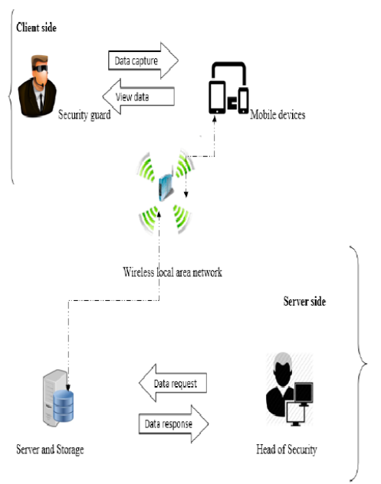

- Women and Road Safety
This Web Application is not only used for Parking Assist, It can also be used in the case Road Accident, Traffic violations etc. The user can enter the Car Number with the GPS location and the fault they did including the locality. Then the police officials can do the necessary. When a woman is being harassed or being followed by a stranger who is doubtable by the women, she can send the GPS information, SMS to near by police station and relatives by a press of a button. This also helps women in a needy and most followed issue, the application is able to display the details and location of all major vehicle repair shop in a locality with best customer reviews and women friendly ones in case of vehicle breakdown and it is also coded to notify the selected contacts when in the case of vehicle breakdown so that they can know their current location and also track the progress of them repairing the malfunction. This ensures the maximum safety of women when struck in any kind of remote areas where their safety is at peril. It basically works like a security application for women can select emergency contacts from their contact list and save them who when they’re in the need of assistance they can simply just at the press of a button call for help.
An application is developed to lodge complains for missing vehicles and we also provide with a follow up with police and the user is able to see the status of the lodged complain through this app. With the help of this application the person who lodges the complain need not have the use to often go to police station and check up on his complain, they can simply use the application.

- Results

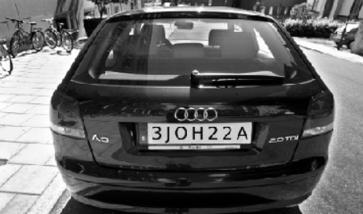
Fig3: grey scaled image

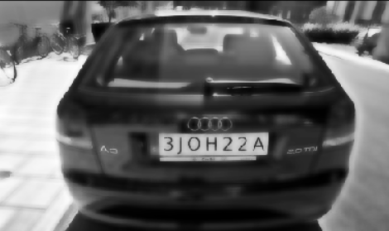
Fig4: Blurred image

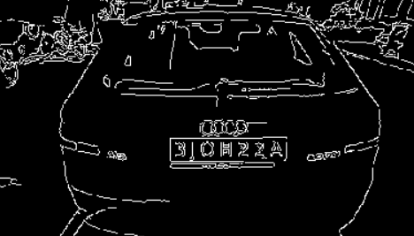
Fig5: Edge image
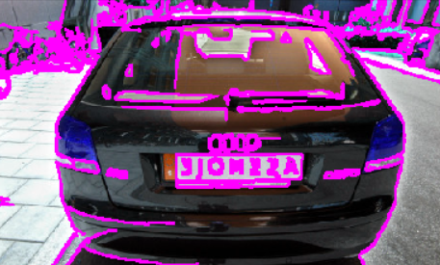
Fig6: contour image

.
Fig10: Final cropped image after character segmentation

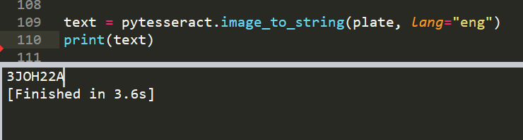
Fig11: Final output in Spyder IDE

- Conclusion
Problems and challenges associated with car park vehicle identification details formed the basis for this research. The main aim of this research was to develop an automatic number plate recognition system for car park management, using Optic Character Reader (OCR) on a mobile device. The OCR process forms the basis of the entire system that was proposed by the researcher as a means of tackling the challenges faced by the security guards during the vehicle entry registration process. The completion of the proposed system resulted in the following benefits:
- Elimination of the hard copy occurrence book and
the need to have to physically write onto the book,
because all the vehicle details records will be
digitized.
- Hastening of the car park vehicle identification
process including the entry and exit process, thus shortening the time duration.
- Accurate recording of vehicle information.
- Provides a means of easy information sharing and
International Journal of Computer Applications (0975 – 8887) Volume 175 – No.7, October 2017 42 information backup.
- Real time information sharing of the vehicles
entering and exiting the Institution to the Head of
Security.
- Easier analysis of the vehicle information captured.

The process what generally occurs here is that first the image gets captured. Then nominally the image is converted into grayscale. After the grayscale conversion we need to filter the image of blurs and another synchronicity error in the image by processing it. Then the image gets cropped only selecting the number plate, this process is specifically done to obtain precise and correct results. The process for cropping the image must be very carefully coded because the software shouldn’t erroneously select any other number present in the image. After the image is cropped and correctly obtained, we need to detect the image and send it for processing further operations. The cropped image simply doesn’t cope, first the image gets segmented through character segmentation so the optical character gets segmented. We basically make the machine learn to detect what alpha numeric character is directed and displayed in the processed image. By doing so we can automate the entire process so even a simpleton like a layman just like that is able to perform these task by the press of a switch or button.

- Reference
- Litman, T.2013. Parking Management Strategies, Evaluation and Planning. Retrieved from http://www.vtpi.org/park_man.pdf
- Subraman T. 2012. Parking Study on Main Corridors in Major Urban Centre. International Journal of Modern Engineering Research (IJMER) ISSN: 2249-6645. Retrieved from
http://www.ijmer.com/papers/vol2_issue3/AE23742748.pdf
- Cornwall. 2009. Drivers on police files for life. Retrieved from http://www.westbriton.co.uk/Drivers-police-files-
life/story-11398048-detail/story.html
- Roberts & Casanova 2012. Automated License Plate Recognition Systems: Policy and Operational Guidance for Law Enforcement. Retrieved from https://www.aclu.org/files/FilesPDFs/ALPR/federal/NHTSA/15948-16075DOJ-IACP%20report.pdf
- ACPO (2013). The police use of Automatic Number Plate Recognition Retrieved from
http://www.acpo.police.uk/documents/crime/2013/201303CBA-ANPR.pdf
- Friedrich, M., Jehlicka, P. & Schlaich, J. 2008.
Automatic number plate recognition for the observance of travel behavior. Retrieved from http://www.isv.uni-stuttgart.de/vuv/publication /downloads/200805_Fr_PJ_JS-ANPR.pdf
- Lotufo, R., Morgan, D. & Johnson, S. 2013. Automatic
license plate recognition (ALPR) a state-of-the-art review. Journal of IEEE transaction on circuits and system for video technology, vol. 23, no, 2013, pp. 311-325 DOI:10.1109/TCSVT.2012.2203741
- Camera-sdk Retrieved from http://www.camera-
sdk.com/p_89-how-to-implement-number-plate-
recognition-in-c-onvif.html
- Reshma, P. 2012. Noise Removal and Blob Identification
Approach for Number Plate Recognition. Retrieved from http://research.ijcaonline.org/volume47/ number8/pxc3879992.pdf

